**PSUC Lab Assignment**

**Lab 2:**

**Q1)** Check whether the given number is odd or even

**Code**:

#include<stdio.h>

int main()

{

int a;

printf("Enter the number\n");

scanf("%d",&a);

if (a%2==0)

printf("the number %d is even\n",a);

else

printf("the number %d is odd\n",a);

printf("My name is Saksham\n");

return 0;

}

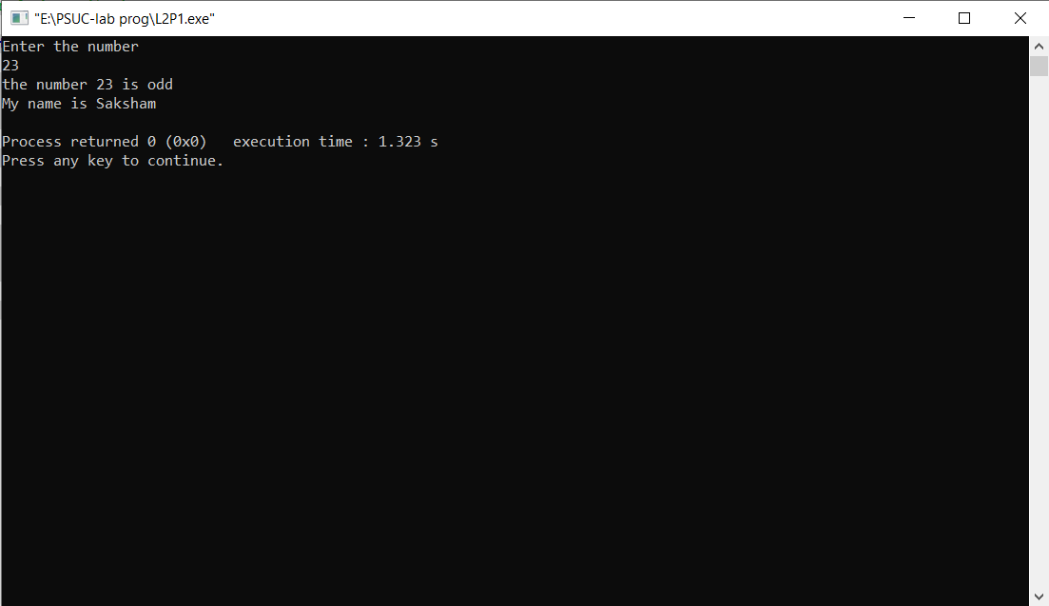**Output**:

Q2) Find the largest among given 3 numbers

Code:

#include <stdio.h>

int main()

{

int num1, num2, num3;

printf("Enter the values of num1, num2 and num3\n");

scanf("%d %d %d", &num1, &num2, &num3);

printf("num1 = %d\tnum2 = %d\tnum3 = %d\n", num1, num2, num3);

if (num1 > num2)

{

if (num1 > num3)

{

printf("num1 is the greatest among three \n");

}

else

{

printf("num3 is the greatest among three \n");

}

}

else if (num2 > num3)

printf("num2 is the greatest among three \n");

else

printf("num3 is the greatest among three \n");

printf("My name is Saksham");

return 0;

}

**Output:**

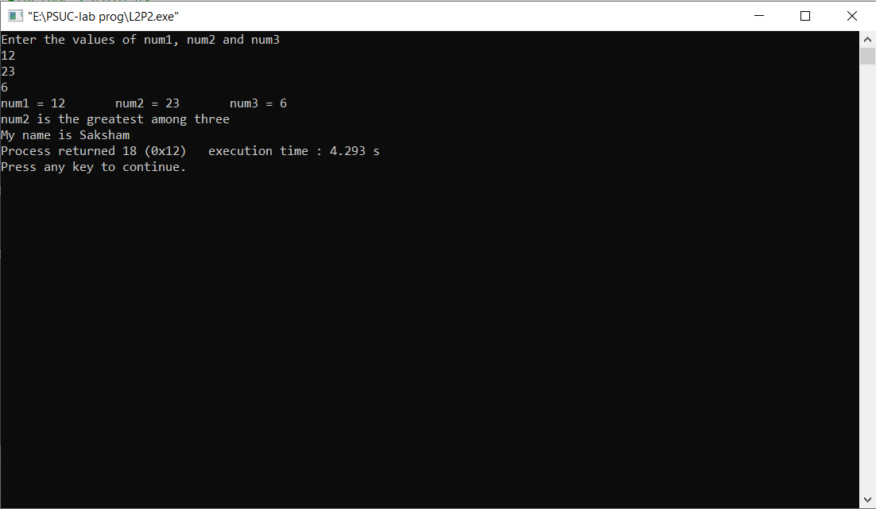

**Q3**) Swap two numbers without using third variable.

**Code**:

#include<stdio.h>

int main()

{

int x,y;

printf("Enter the numbers x and y respectively\n");

scanf("%d%d",&x,&y);

x = x+y;

y = x-y;

x = x-y;

printf("The value of x is %d\n",x);

printf("The value of y is %d\n",y);

printf("My name is Saksham");

return 0;

}

**Output:**

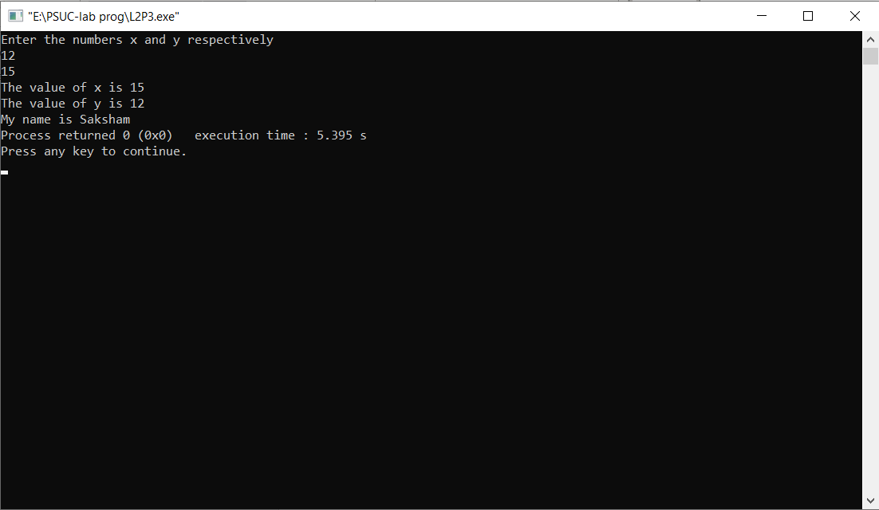

**Q4**) Compute all the roots of a quadratic equation using switch case statement.

**Code**:

#include <stdio.h>

#include <math.h>

int main()

{

float a, b, c;

float root1, root2, imaginary, discriminant;

printf("Enter value of 'a' of quadratic equation (aX^2 + bX + c): ");

scanf("%f", &a);

printf("Enter value of 'b' of quadratic equation (aX^2 + bX + c): ");

scanf("%f",&b);

printf("Enter values of 'c' of quadratic equation (aX^2 + bX + c): ");

scanf("%f",&c);

discriminant = (b * b) - (4 * a * c);

switch(discriminant > 0)

{

case 1:

// If discriminant is positive

root1 = (-b + sqrt(discriminant)) / (2 * a);

root2 = (-b - sqrt(discriminant)) / (2 * a);

printf("Two distinct and real roots exists: %.2f and %.2f",

root1, root2);

break;

case 0:

// If discriminant is not positive

switch(discriminant < 0)

{

case 1:

// If discriminant is negative

root1 = root2 = -b / (2 * a);

imaginary = sqrt(-discriminant) / (2 * a);

printf("Two distinct complex roots exists: %.2f + i%.2f and %.2f - i%.2f",

root1, imaginary, root2, imaginary);

break;

case 0:

// If discriminant is zero

root1 = root2 = -b / (2 * a);

printf("Two equal and real roots exists: %.2f and %.2f", root1, root2);

break;

}

}

printf("\nMy name is Saksham");

return 0;

}

**Output**:

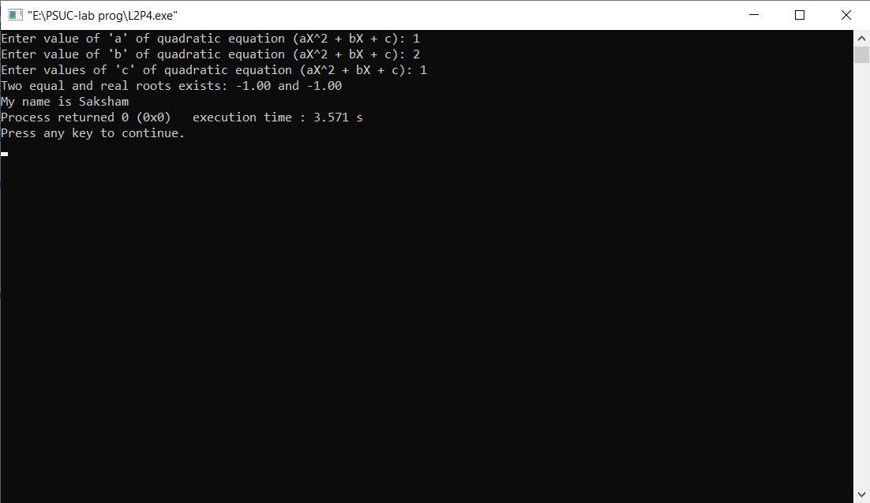

Q5) Write a program that will read the value of x and evaluate the following function Use else if statements & Print the result (‘Y’ value).

Y = 1,x>0 ; Y=0,x=0;Y=-1,x<0

**Code**:

#include<stdio.h>

int main()

{

int x,Y;

printf("Enter value of x\n");

scanf("%d",&x);

if (x>0)

printf("the value of Y is 1");

else if (x<0)

printf("the value of Y is -1");

else

printf("the value of Y is 0");

printf("\nMy Name is Saksham");

return 0;

}

**Output**:

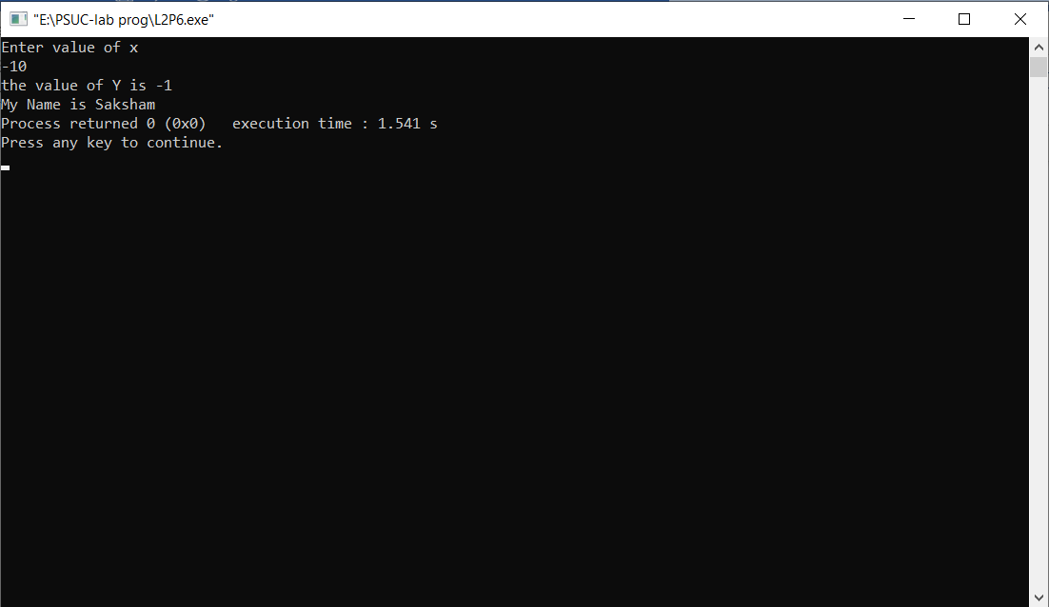

**Q6)** Find the smallest among three numbers using conditional operator.

**Code:**

#include<stdio.h>

int main()

{

int a,b,c;

int small;

printf("Enter three numbers\n");

scanf("%d%d%d",&a,&b,&c);

small = (a<b)?((a<c)?a:c):(b<c)?b:c;

printf("the smallest is %d\n",small);

printf("my Name is Saksham");

return 0;

}

**Output:**

